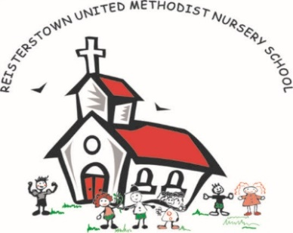
Reisterstown United Methodist Nursery School
Summer Camp
246 Main Street
Reisterstown, MD 21136

Contract for Summer Camp Program

I have read the Parent Handbook for summer childcare at RUMNS. I understand and agree to the statements as written and will abide by them. If I ignore or abuse these policies, including excessive late pickups, I understand that I may be asked to find alternative childcare.

I agree to pay the childcare fees as stated below, and to be prompt with payment. Payment is due on the Monday of each week of camp. I understand that that if payment is not made on time, my child may not participate in RUMNS’s program.

My Child will be participating in the following weeks of the Summer Program:

_____Week 1 June 29-July 3 Art and Artists

_____Week 2 July 6-July 10 Camping Adventures

_____Week 3 July 13- July 17 Ancient Egypt and Moses

_____Week 4 July 20-July 24 Animal Habitats

_____Week 5 July 27-July 31 The Olympics

_____Week 6 August 3-August 7 Ancient Rome and Paul

_____Week 7 August 10-August 14 Our Green Earth

_____Week 8 August 17-August 21 S.T.E.M. Exploration

Summer total for all 8 weeks is $1440.

There is a $50 discount for campers paid in full for full summer by June 1, 2020. We alternatively offer a 5% sibling discount for 2 or more children. (Children AFTER the 1st are eligible for 5% OR paid in full discount.)

FEES: $180 per week (7:45am-5:30pm; breakfast, morning and afternoon snack included) LATE PICKUP FEE: $2 per minute, per child, after 5:30pm. Please be prompt.

Cash, check, or money order accepted. Please make check payable to RUMNS. A fee of $35 will be charged for all returned checks.

Child’s Name:_____________________________________________ Age:______

Parent’s name (printed):_________________________________________________________

Parent’s Signature:_____________________________________________ Date:____________

