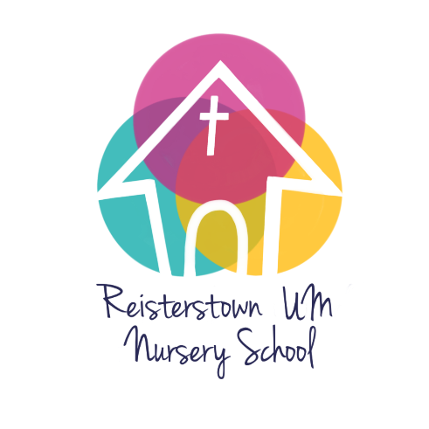

Reisterstown United Methodist Nursery School 2022-2023 Calendar

August 2022 31 Parent Meeting in Church library 6:30 pm

September 2022 5 Labor Day – closed
6 School starts all classes

October 21 Maryland State Teacher Conferences (MSDE) – closed
28 School pictures

November 11 Church event closure
24, 25 School closed – Thanksgiving

December 15 All classes Christmas Program – 11:00 a.m.
22-31 School closed for Christmas –

January 2023 3 School reopens
16 School closed for MLK
February 20 School closed for President’s Day

March

April 3-9 SCHOOL CLOSED for spring break
10 School closed for parent conferences
11 School re-opens

May 29 School closed for Memorial Day

June 15 4’s graduation 11:00 - Sanctuary –
15 Last day in classrooms
16 School picnic –11:00 – 1:00 at Reisterstown Regional Park

Your child’s teacher will provide you with a class calendar containing specific events related to your child’s program

Updated 7/26/22

