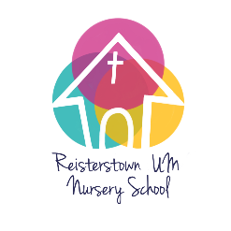
Reisterstown United Methodist Nursery School
2023-2024 School Year (September 5 – June 14)
Three-Year-Old Class Registration

PLEASE PRINT CLEARLY (especially email contacts)
Child’s Full Name: ______________________________________Nickname: ___________________________
Parent/Guardian’s Name: _________________________________ Relationship to the child: ______________
Address: __________________________________________________________________________________
Cell Phone: ________________________ Email Address: __________________________________________
Parent/Guardian’s Name: _________________________________ Relationship to the child: ______________
Address: __________________________________________________________________________________
Cell Phone: ________________________ Email Address: __________________________________________
With whom does the child live? ___________________________________ Child’s Birth Date: _____________
Primary Language Spoken in the home? (to help us with communication) ______________________________
Allergies/food concerns _____________________________________________________________________

____________ Half Day Program: (8:50 am – 12:00 pm: Monday thru Friday) $3,750 *

____________ Full Day Program A: (7:30 am – 5:30 pm: Monday thru Friday) $8,850*

What time will you drop off? _________ What time will you pick up? __________

3’s must be 3 years old before 9/1/23 and potty trained

I give permission to include this information on a class roster sheet __________________________________
(sign)
How did you hear about our program? _________________________________________________________

Enclose $125 non-refundable Registration Fee made out to RUMNS with this form to:
Reisterstown United Methodist Nursery School
246 Main Street, Reisterstown, MD 21136
Attention Lani Hoffmann

Please provide a copy of any IEP, IFSP, or other educational or behavior plan that you are using in conjunction with professionals with whom you are currently working.
Please provide a copy of any custody agreements that affect the child’s daily schedule and living arrangements.
* Tuition can be paid in monthly or bi-monthly installments.

Questions? Contact Lani Hoffmann, Registrar at 443-996-9375 or rumns234@gmail.com

