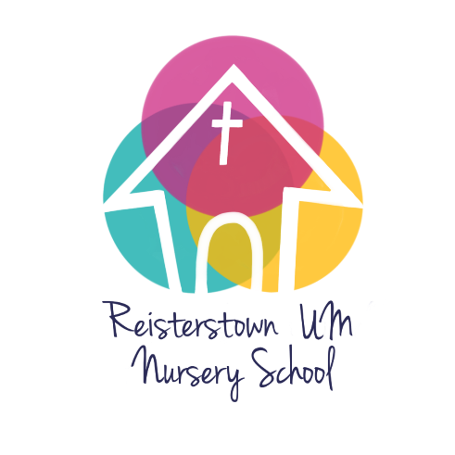

Reisterstown United Methodist Nursery School 2022-2023 Calendar (draft)

September 2022 Parent Meeting
5 Labor Day – closed
6 School starts all classes

October 21 Maryland State Teacher Conferences (MSDE) – closed

November 11 Church event closure
24, 25 School closed – Thanksgiving

December 22-31 School closed for Christmas –

January 2023 3 School reopens
16 School closed for MLK
February 20 School closed for President’s Day

March conferences TBD

April 3-10 SCHOOL CLOSED for spring break
11 School re-opens

May 29 School closed for Memorial Day

June 15 4’s graduation 11:00 - Sanctuary –
15 Last day in classrooms
16 School picnic –

All dates are subject to change. This calendar is based on information known to us at this time.
Your child’s teacher will provide you with a class calendar containing specific events related to your child’s program
Updated 2/6/22

